Brian Box User Manual
Developed in Ukarumpa PNG

Introduction:
The Brian Box electronic module was specifically designed to provide economic and high reliability charging methods for hand held electronic devices such as mobile phones, tablets and other devices that uses 5V USB charging method. The Brian Box electronic module can handle and charge up to 2 (two) hand held electronic devices in the same time. This particular design can directly connect to the solar panel and does not require any battery in between the solar regulator and the actual phone charger. For this reason, the Brian Box module ensures functionality for significantly longer period of times pass the average lifetime of a rechargeable battery. Moreover, it reunites the solar regulator and the phone charger in one single device at a convenient market price.

Product specifications
 | Min | Typ | Max | Unit | Comment
Operating voltage | 6 | 22 | 40 | V
Output voltage | 4.98 | 5 | 5.057 | V
Input current | - | - | 3 | A
Output current | - | - | 2.5 | A
Operating frequency | - | 150 | - | KHz
Internal shut down temperature | - | - | 125 | ⁰C
Maximum case temperature | - | - | 90 | ⁰C | For 10 min
Overload and short circuit protection | - | - | 3 | A

How to use
Connect the Brian box electronic module to the solar panel and plug in the charger chord for the mobile phone or the desired hand held device you want to charge via the USB connector. Connect your device to the USB charger chord and wait for the device to charge.
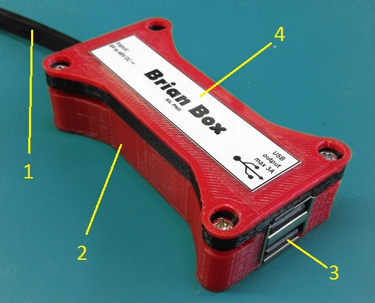
Quick parts description list
1 | Input chord
2 | Plastic case
3 | Output USB connector
4 | Descriptive label

Environmental, ECO and materials information
The Brian Box electronic module uses non-toxic PLA plastic case. This type of plastic is approved and considered to be environmental friendly and biodegradable. The PCB might contain lead mixture materials. Do not throw away at the end of the life cycle. Dispose this device in the special places designated for collecting old electronic devices for recycling.
The device internal DC-DC converter produces a switching noise of around 150KHz. This noise might temporarily affect in some cases fine-tuned radio equipment such as radio stations.

Warnings and precautions!
- Do not expose the device to fire or direct liquid contact! In case of water contact (or other liquids), the Brian Box conductive materials might corrode and damage the entire device.
- Store in a dry place!
The device is covered with a layer of coating that prevents the metal oxide to be formed. Still, the recommendation is to keep it in an environment that usually has less than 85% humidity at all times.
- Do not strip or cut the input cable to connect to different voltage sources! Do not connect to other power points or AC outlets! Risk of electric hazard!
- Not suitable for children!
Choke hazard, in case of raping the power cord around the neck! If the device comes apart, it contains small parts that can detach from the PCB in some cases. Small parts can lead to severe injuries or choking if swallowed.
- The manufacturer and the designers does NOT assume any responsibility for any injury or inconvenience that might result out of improper use or disposal of this particular device and its accessories.

